35.57: For maximum intensity, with a half-cycle phase shift,
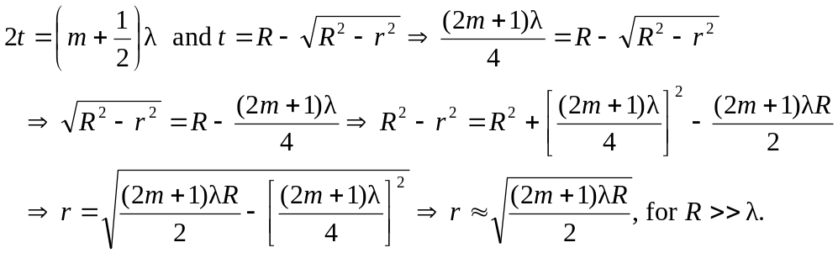
The second bright ring is when 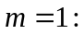
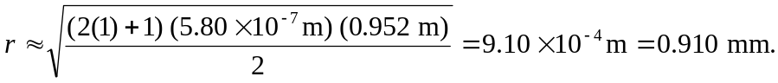
So the diameter of the third bright ring is 1.82 mm.

